Deliverable #3
Group name: liam-n-pham

Hypothesis 1: Age and Spending
- Question: Do middle-aged customers spend significantly more than younger or older customers? (Young <30, Middle 30–55, Older >55). This is a three-sample test.
- Variables:
  - Independent: Age Group
  - Dependent: Total Spent (aggregated per customer)
- Step 0 – Pre-Analysis Plan
Research question: “Do middle-aged customers (30–55) spend more per customer than younger (<30) or older (>55) customers once spending is aggregated per customer?”
- Our goal: To determine whether middle-aged customers (30–55) have higher average total spend per customer than younger (<30) or older (>55) customers in the dataset, so we know which age segment drives revenue.
- Our data:
  - Dataset: Sales_Cleaned
  - Independent variable: categorical Age Group with bins Young (<30), Middle (30–55 inclusive), Older (>55).
  - Dependent variable: Total Spent, the aggregated spend per unique customer.
  - Supporting columns: raw Age (to build bins) and CustomerID (for grouping).
  - Data decisions: because Sales_Cleaned is already the processed dataset from Deliverable #2, no extra cleaning steps are planned beyond keeping the columns needed for the analysis.
- Significance level : α = 0.05.
- Step 1 – State the Hypotheses
- Null hypothesis (H₀): The average total spend is same for young, middle, and older customers (μyoung = μmiddle = μolder).
- Alternative hypothesis (H₁): At least one age group has different average spend but don’t know which one.
- Type I error: With α = 0.05 we accept a 5% risk of rejecting H₀ even though the age-group means are actually equal.
- Type II error: We might miss a real difference, we fail to reject H₀ when the means truly differ.
- Step 2 – Identify the Test Statistic and Its Distribution
- Type of data: Dependent variable is continuous (total spend per customer).
- Number of groups: Three independent age groups: Young, Middle, Older.
- Sample size & population variance: Sample sizes are above 30 but population σ is unknown.
- Study design & hypothesis: Independent groups, overall hypothesis (“at least one mean differs”).
- Parameter of Interest: Mean of total spend per customer for each age group
- Test statistic: one-way ANOVA F-test because we’re comparing three independent group means with unknown population variances and the study question is the overall “do any means differ?”.
- I’ll check independence and the QQ plots for reasonableness, then proceed with the standard one-way ANOVA

- Step 3: Collect Data And Compute the Test Statistic
EXCEL:
- I group the rows by Customer ID, calculate each person’s total spend, and then flag them as Young (<30), Middle (30–55), or Older (>55). This gives one clean row each customer.
- On Hyp1_Excel I calculate the descriptive statistics for each group:
  - Young: n = 177, mean = 10,702, s = 9,313
  - Middle: n = 527, mean = 14,628, s = 11,023
  - Older: n = 296, mean = 9,907, s = 7,700
- Boxplots give a quick visual of each group’s spread, median, and any extreme spenders so we can see if one group sits higher or has more outliers.
- QQ plots compare each group’s spending distribution to a normal line; they let you check whether the ANOVA normality assumption is roughly okay (straight line) or badly violated (big curves).
- Next I used Excel’s Data Analysis ToolPak (ANOVA: Single Factor) with the three spend columns. The output shows:
  - p-value = 1.5591e-11

Source of Variation | Sum of Squares (SS) | Degrees of Freedom (df) | Mean Square (MS) | F-Statistic
Between Groups | 4,948,080,947.66 | 2 | 2,474,040,473.83 | 25.5159
Within Groups | 96,669,974,576.80 | 997 | 96,960,857.15
Total | 101,618,055,524.46 | 999

PYTHON
- Exported the cleaned customer table from Hyp1_Workbook.xlsx to hyp1_data.csv (same columns: Customer ID, age, age group, and total spend).
- Ran hyp1_analysis.py, which loads that CSV and computes the ANOVA table:
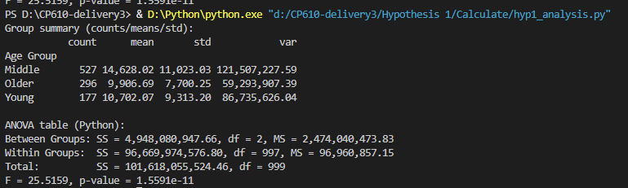

- Step 4: The P-value And The Decision Rule
From both Excel and Python, the one-way ANOVA returns F = 25.5159 with p = 1.5591e-11
Decision rule: with α = 0.05, reject H₀ if p < 0.05.
Since p < 0.05, we reject the null hypothesis and conclude that at least one age group’s mean total spend differs. The middle-aged group’s mean ($14.6k) is noticeably higher than the young ($10.7k) and older (~$9.9k) groups, so they are the segment driving the difference

- Step 5: State The Conclusion
There is statistically significant evidence at the α = 0.05 level to conclude that average customer spending is not the same across the three age groups.
In our data the middle-aged customers (30–55) have the highest average spend, so they spend more per customer than the young (<30) and older (>55) groups.

